LANE AND TRAFFIC SIGN DETECTION FOR AUTONOMOUS VEHICLES IN INDIAN ROAD CONDITIONS USING YOLOv8n

*H. S. Gowri Yaamini*

*Department of Computer Science,*

*Amrita School of Computing,*

*Amrita Vishwa Vidyapeetham*

*Mysuru Campus, India* [*gowriyaamini@gmail.co*](mailto:gowriyaamini@gmail.com)*m*

*Swathi K. J*

*Department of Computer Science,*

*Amrita School of Computing,*

*Amrita Vishwa Vidyapeetham*

*Mysuru Campus, India*

[*swathirao2251@gmail.com*](mailto:swathirao2251@gmail.com)

*Dr. Manohar N*

*Department of Computer Science*

*Amrita School of Computing*

*Amrita Vishwa Vidyapeetham*

*Mysuru Campus, India*

*n_manohar@asas.mysore.amrita.edu*

*Abstract:*

***Accurate and precise detection of lanes and traffic signs is predominant for the safety and efficiency of autonomous vehicles and these two significant tasks should be addressed to handle Indian traffic conditions. There are several state-of-art YOLO models trained on benchmark datasets which fails to cater the challenges of Indian roads. This paper introduces a YOLOv8n Transfer Learning approach by adjusting architecture for lane and traffic sign detection in Indian diverse Urban, Suburban, and Highway scenarios. Leveraging the strength of YOLOv8, the architecture streamlines solutions by adding additional convolutional blocks for segmentation task and incorporating CBAM for detection to enhance the feature extraction achieving high precision even in complex scenarios like crude weathering and traffic conditions, partially occluded and partially erased lanes, and traffic signs. However, the YOLOv8 algorithm faces challenges in detecting small targets and shows latency in inference but gives better precision results and YOLOv8 nano variant is widely used as it is computationally less complex during deployment compared to other variants. Through rigorous evaluations of diverse datasets, including crowded roads, day, night, mist, fog, rain, cloud environments, curved roads, and partially visible markings the proposed YOLOv8n models exhibits remarkable performance. Specifically, lane detection model achieves an impressive mean Average Precision (mAP) of 90.6% with an inference speed of 117 frames per second (fps) whereas, a notable mAP of 81.3% for traffic sign detection model with a processing speed of 56 fps. This indicates that models need to be trained with a wide variety of Indian data samples for the autonomous vehicles to perform better in India.***

***Keywords—Object Detection, YOLOv8n, Lane Detection, Traffic Sign Detection, CBAM, Data Augmentation, Ghost Convolution***

1. INTRODUCTION

Lane and traffic sign detection in deep learning involves identifying objects in images or videos, essential for applications such as self-driving vehicles, surveillance, clinical imaging, and robotics. The autonomous vehicle domain focuses on locating predefined objects like lanes, cars, pedestrians, traffic signals, and animals by identifying bounding boxes. The evolution of autonomous driving technology emphasizes the need for robust perception systems, imitating human-like environmental understanding. Lane detection is critical for precise navigation, employing computer vision techniques and deep learning algorithms to identify road markings and outline vehicle paths. These algorithms must adapt to diverse conditions to ensure accuracy. Similarly, traffic sign detection is essential for informed decision-making, adherence to regulations, and navigation optimization. The integration of these detection components enhances accuracy, efficiency, and seamless navigation within autonomous vehicles. Technologies like YOLO are crucial for evaluating detection algorithms' accuracy, speed, and robustness. As automation advances, significant research emphasizes autonomous vehicles, offering safety, efficiency, accessibility, and economic benefits by revolutionizing transportation. This paper aims to develop perception systems capable of accurately detecting both lanes and traffic signs, particularly on Indian roads striving to develop intelligent systems capable of navigating complex road scenarios in India and similar environments globally.

The proposed system can be extended beyond autonomous vehicles, contributing to surveillance systems and advancing computer vision in complex environments. By evaluating diverse scenarios, the research ensures safer navigation, fosters trust in autonomous systems, optimizes traffic flow in smart cities, and enhances urban safety. The system's adaptability holds significant promise for emerging technologies, reshaping the landscape of interconnected and autonomous systems in daily life. Through thorough evaluation and implementation, the research advances intelligent systems, laying the groundwork for future transportation defined by enhanced safety and efficiency.

This paper addresses the challenges within Indian road scenarios like partially occluded or erased lanes and traffic signs, crowded roads with unsystematic traffic regulations along with pedestrians and animals on the road, roads with intricate curves, roads under varied times of day and weather conditions like rain, fog, and mist, and harsh weathering of traffic sign boards and lane markings in urban, suburban and highway instances. While current state-of-art models excel with benchmark datasets, they underperform when deployed on Indian traffic scenarios, hence, a model which is trained against such challenges is required. To serve such a demanding task, the YOLOv8n model is adjusted with additional convolutional layers for lane segmentation, and CBAM is integrated for enhanced feature extraction along with Ghost Convolutional layers for traffic sign detection.

1. LITERATURE SURVEY

YOLOv8-ghost-EMA, a lightweight traffic sign detection method that is tailored for embedded devices [1] leverages the Fusion of Efficient Multi-Scale Attention Module with GhostNet backbone, which enables efficient cross-spatial learning. Achieving 93.5% mAP on CCTSDB in poor weather and 82.9% on TT100k datasets, with an inference delay of 0.79s on Raspberry Pi 4B, it excels previous YOLO versions in speed, memory, and accuracy. However, it lacks detailed implementation and hyperparameter information. Whereas YOLOv8 with EfficientNet as the backbone for real-time road safety alerts [2] , utilizes a custom dataset with augmented shadows for enhanced practicality. It achieves exceptional accuracy and speed, handling challenges like shadows, occlusions, and scale variations, with a mAP-50 score of 0.995 and a mAP-50-95 score of 0.802 at 640-pixel image size by facing challenges such as acquiring more data, computational resources, and distant sign detection, despite dependency on data quality and hyperparameters.

A real-time detection and classification system for traffic signs and road lanes using YOLOv8, ResNet50, and DCNN [3] is proposed for better feature selection and classification. Despite achieving high accuracies of 99% for traffic sign recognition and over 97% for lane recognition across diverse environmental conditions, the study lacks comparisons with existing methods, discussion of limitations, and thorough experimental analysis. Similarly, a Traffic Sign Recognition system for Turtlebot3 Robot using YOLOv8 and SIFT [4] has been proposed which has achieved high accuracy and real-time performance yielding a 99.5% mAP@0.5 while reducing computational time. However, YOLOv8 consumes more computational resources.

CR-YOLOv8, a model enhancing multi-scale traffic sign detection accuracy using CBAM [5] addresses challenges in small object detection while maintaining real-time performance with features like SPPF. Despite slight increases in model size, improvements are needed for performance in adverse weather conditions. CBAM is also employed [6] to focus on automatic pavement crack identification using an improved YOLOv8 model to detect cracks quickly and accurately. Utilizing Depth-wise separable convolution and CBAM, the model achieves high precision, recall, F1-score, and mAP@0.5, surpassing a 90% recognition rate, and F1-score of more than 97%. Challenges include the need for significant data and computational resources. YOLOv8-CB introduced for a dense pedestrian detection algorithm tailored for challenging environments like dense crowds and occlusions [7] integrates YOLOv8n and CBAM, showing competitive performance. However, there's room for improvement in detecting severely occluded pedestrians, and the frame rate is comparatively reduced. It sacrifices a bit of detection speed for higher accuracy, aiming to enhance feature representation and localization, resulting in a lighter model with improved accuracy.

The study focus on object detection in adverse weather conditions using DAWN and ACDC datasets, incorporating various harsh weather scenarios which employs CNN, YOLO, and DSNet with data augmentation significantly enhancing detection performance by merging datasets [8]. Challenges include a lack of explicit sun glare handling, and manual annotations for order correction and additional object inclusion. Annotations cover diverse distances for early detection with YOLOv8 as key methodologies for improved performance. In the same light, another research propose to optimize YOLO performance for traffic light detection and steering control in Gazebo-ROS2 [9] by training with synthetic datasets like CinTA_v2 and GathoTF, achieving a high mAP of 98.5% with YOLOv8 improving lane-keeping accuracy. However, the study lacks an exploration of complex scenarios like intersections and real-world validation. Likewise, for improved traffic sign detection, an enhanced YOLOv8 model has been employed [10] to leverage the TT100K dataset and integrate data augmentation techniques which aids in small object detection, resulting in a notable increase in mAP by 3.31% and recall by 3.59% compared to the base YOLOv8 model. Despite a slightly lower mAP with YOLOv8+DA, the algorithm effectively reduces missed detections and enhances accuracy.

The research proposes a road sign recognition system using YOLOv8, focusing on Moroccan road signs with a self-created dataset of twenty classes from various sources [11]. Augmented with FPN, the model achieves an impressive accuracy of 95% for both images and videos. The study highlights YOLOv8's rapid detection and classification capabilities for road signs but lacks an explicit discussion of limitations. Another YOLOv8 experimentation with a benchmark dataset [12] introducing YOLOM, a real-time multi-task framework based on YOLOv8 using the BDD100K dataset with multi-task annotation. It achieves high performance with mAP50 of 81.1% for object detection and IoU of 28.8% for lane line segmentation. Despite the lower recall, its lightweight and adaptive nature makes it suitable for various segmentation tasks.

The paper introduces a lightweight convolutional neural network (Lw-CNN) [13] to address low accuracy and poor real-time performance in complex traffic scenes. Utilizing the CCTSDB dataset, they employ MobileNet-V2 + DeepLab-V3 for segmentation and recognition, resulting in a recognition accuracy of 99.92%. Despite sacrificing accuracy due to parameter reduction, the method achieves high accuracy and robustness with low memory usage and fast inference time in various complex scenarios. A CNN-based combined U-Net and YOLO model variant has been proposed [14] employing encoders and decoders for real-time lane and object detection, emphasizing minimal latency and performance by utilizing CULane benchmark and custom datasets. Despite challenges in adverse conditions and complex scenarios, the approach proves computationally efficient and scalable.

The existing research collectively investigates diverse methodologies to advance object detection and recognition. Notable contributions from [1] and [2] focus on real-time traffic sign detection, leveraging techniques like YOLOv8 to achieve remarkable accuracy and speed. In contrast, studies by [6] and [7] tackle challenges such as dense crowds and pavement crack identification using refined iterations of the YOLOv8 model, showcasing elevated precision and recall rates. Despite prominent progress, challenges persist, and these include effectively managing diverse scenarios, managing computational resource demands, and conducting robustness analysis. Nonetheless, techniques such as data augmentation and lightweight architectures show promise for practical applications in traffic management and infrastructure maintenance. Moving forward, continued exploration and refinement are essential to support scalability and generalization. Advancements in these areas will further enhance the effectiveness and applicability of object detection methodologies across a range of real-world scenarios.

1. PROPOSED SYSTEM

Proposed is a Traffic Lane and Sign Detection system which aims towards detecting lanes and signs in a video simultaneously as shown in Figure 1. The proposed flow model is employed by manually scraping data from online sources and preparing it to train and validate the model. Later, the model is tested on videos to detect traffic lanes and signs which makes this an experimental project.

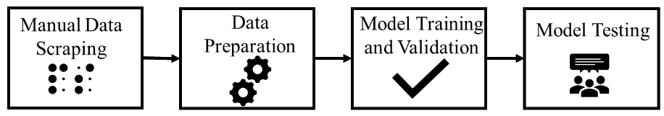  
**Figure 1. Proposed flow Diagram**

* 1. Data Collection and Preparation

The architecture of the proposed system begins with manual data scraping from online platforms and further these images undergo the preprocessing phase where their dimensions are standardized to 1920 x 1080 pixels to maintain consistency. Additionally, precise semantic segmentation masks are thoroughly crafted for the lane markings, while the bounding boxes are annotated for traffic signs which results in accurate detection. Later, the created annotations are formatted to save in YOLO format and then integrated into the training phase to assist the model in learning with the corresponding images as illustrated in Figure 2.

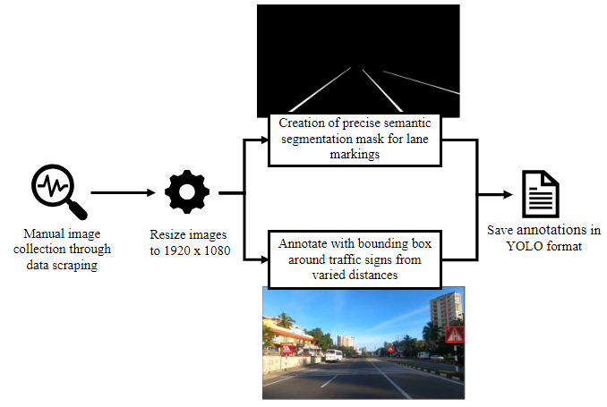

**Figure 2. Architecture diagram of dataset collection and preparation**

* 1. Training

Primarily, the proposed system is divided into 3 major phases namely Training, Validation, and Testing. Proceeding to model training depicted in Figure 3, the dataset, comprising both lane and traffic sign data, is split into training (70%), validation (30%) in every instance to ensure robust evaluation. The lane and sign models are trained individually with the dataset for better performance.

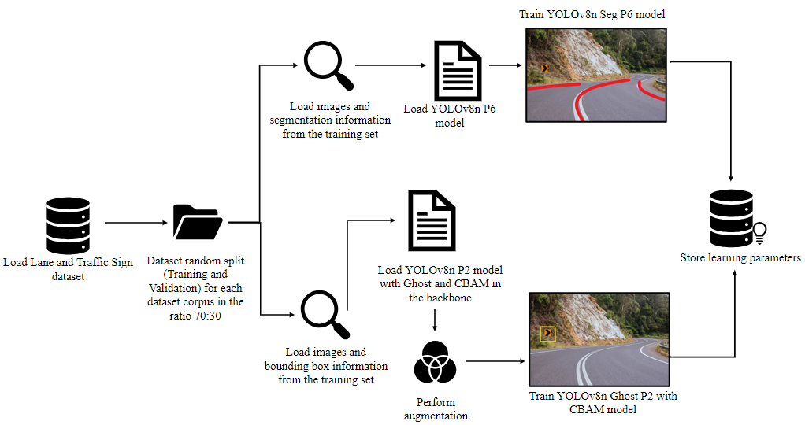**Figure 3. Architecture diagram of Model training**

3.2.1 Lane Segmentation Architecture

Lane-related images, along with their segmentation information, are fed into the YOLOv8n Seg P6 model for training, leveraging its hierarchical feature extraction capabilities through a six-layer backbone architecture. The YOLOv8n Seg P6 architecture mentioned in Figure 4, dedicated to lane segmentation tasks, stands out for its efficient design as it comprises of a six-layer backbone which is P1 to P6 aimed at hierarchical feature extraction from the given input images. Notably, a Spatial Pyramid Pooling Feature (SPPF) block is incorporated post-convolutional layers, enabling multi-scale feature extraction crucial for accurate lane segmentation. The architecture is further strengthened by a C2f (shortcut) module, unique to YOLOv8, which enhances features while minimizing computational complexity through dense and residual structures. This module facilitates feature transformation and channel adjustments, ultimately optimizing lane detection performance. Overall, the YOLOv8n Seg P6 architecture integrates advanced backbone and neck architectures to achieve precise and efficient lane segmentation, marking a significant advancement.

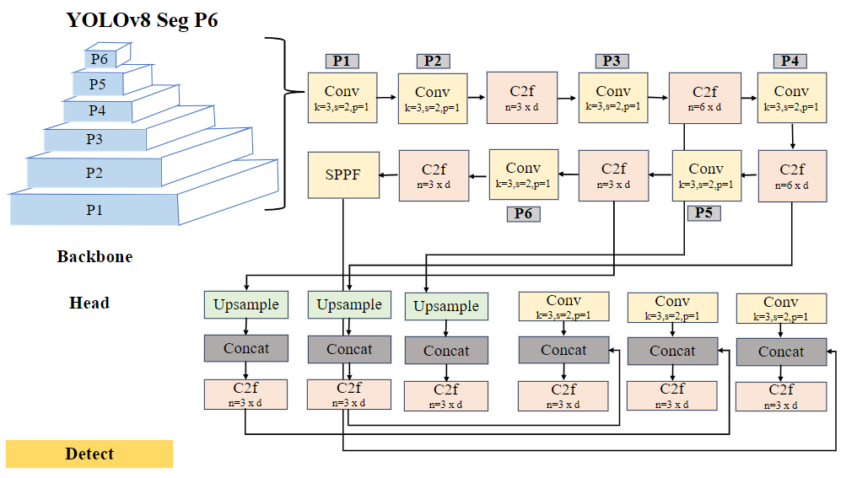  
**Figure 4. The architecture of YOLOv8n Segment P6 for Lane Segmentation**

In backbone of the architecture, the YOLOv8n model is adjusted with six of the convolutional layers [41] to extract and transform input data into meaningful feature representations in segmentation task by applying 3x3 kernels to capture spatial details. The output at each layer is computed as:

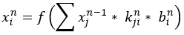

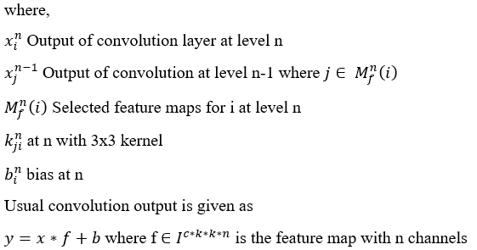

YOLOv8n employs SiLU (Sigmoid Linear Unit) [42] activation function in the CNN block after batch normalisation due to its ability to stabilize values independently and to maintain non-monotonic behaviour throughout convolution layers. Considering its function of unbounded non-linearity, SiLU is retained in the network for handling complex relationships and gradients crucial for lane and traffic sign detection. It is a product of sigmoidal function which can be defined as:

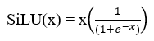

Upsampling in the head of the architecture maintains the aspect ratio of the original image, which is 1920x1080 in the currently used dataset using the nearest neighbor method [43] and to effectively handle small targets, image size of 1088 is given for model training which scales the images from 1920x1080 to 1088x612. This method ensures that important small target features are preserved for accurate detection. The height h and width w are adjusted i.e., hr=h/612 and wr=w/1088 and calculated using the formula:

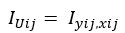

where,







Here, i and j denote the row and column indices of the upsampled image IUij, respectively.

3.2.2 Traffic Sign Detection Architecture

The traffic sign data undergoes training on the YOLOv8n P2 model with Ghost and CBAM architecture, enhancing its detection accuracy. Data augmentation techniques are employed to further improve the generalization capabilities of the traffic sign detection model, ensuring reliable performance in diverse Indian road scenarios.

The YOLOv8n Ghost P2 with CBAM architecture portrayed in Figure 5, is tailored for traffic sign detection which presents a sophisticated backbone comprising Convolutional, Ghost Convolutional, C3, and CBAM layers, enabling hierarchical feature extraction across different scales. The architecture is augmented with an SPPF layer, filtering feature processing by integrating outputs from P2 and CBAM. The head section incorporates Ghost Convolution layers, Concatenation, and C3Ghost blocks which mainly aids in enhancing the feature representation, along with an Upsample layer for incorporating feature maps, improving spatial resolution for precise object localization that is necessary to locate and localize the traffic signs. The traffic sign model has been employed with data augmentation techniques that involve applying transformations to the training dataset that results in enhanced diversity.

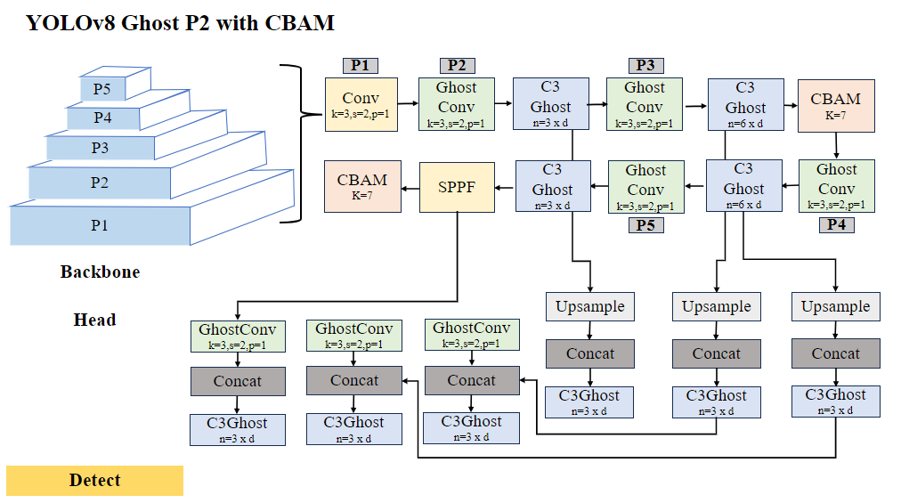  
**Figure 5. The architecture of YOLOv8n Ghost P2 with CBAM for Traffic Sign Detection**

In the sign detection model, Ghost convolution [44] is utilized alongside the convolutional layers and upsampling techniques to optimize computational efficiency without sacrificing performance. The usual convolution output is given as:



However, this lightweight variant reduces computational load by employing fewer channels (m ≤ n) to generate feature maps to handle small targets using the convolutional operation 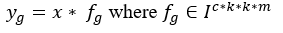 . It achieves this by linearly combining convolutional operations using a linear operator 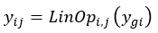, where i=1, ...., m and j=1, ...., p and subsequent ReLU activation to introduce non-linearity ReLU(x) = max (0, x). Notably, omitting bias terms further updates computation, making Ghost convolution well-suited for scenarios requiring precise yet lightweight convolutional operations, such as in traffic sign detection.

3.2.2.1 Convolutional Block Attention Module (CBAM)

CBAM is integrated into the backbone section of the YOLOv8 P2 model to enhance feature extraction as it dynamically enhances feature maps by focusing on relevant regions through channel and spatial attention mechanisms. It helps in extracting deep features including the far, occluded and partially visible signs with the help of Channel attention that assigns importance weights to informative channels, while spatial attention improves pixel-level localization accuracy to enhance detection. Through channel attention, CBAM assigns weights to channel features, highlighting crucial information and capturing relevant information and insights. Simultaneously, spatial attention enables the model to concentrate on specific regions of interest.

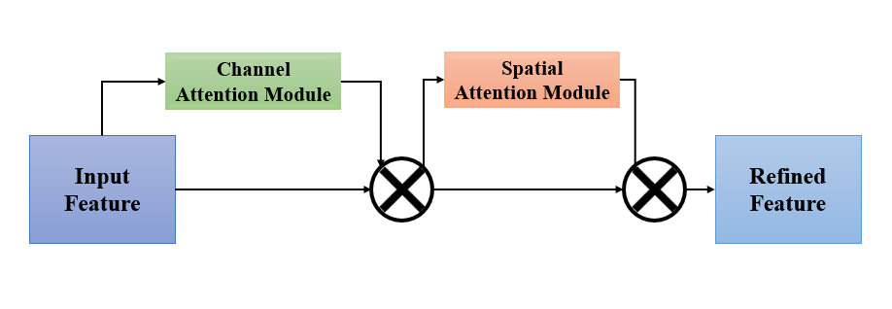**Figure 6. CBAM Mechanism**

Given an input feature map IF ∈ IC * H * W , a 1D channel attention map CF, 2D spatial attention map SF,. The CBAM [45] attention mechanism process’ output refined feature can be outlined as OF:

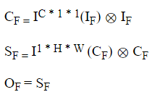

where,

Input feature IF ∈ IC * H * W

Output refined feature as OF

3.2.2.2 Data Augmentation

Data Augmentation techniques like horizontal and vertical flips introduce variations in object orientation, while HSV value adjustments handle changes in lighting and color. Rotation aids in viewing data in different angles, and perspective transformation simulates varying viewpoints. Mosaic augmentation combines images which aid in enhanced learning of the features and mixup generates new examples, improving model generalization for better learning and reduced overfitting risk.

* 1. Validation and Testing

Throughout the training phase, learned parameters are preserved for subsequent stages of the process, ensuring continuity and consistency in model performance as shown in Figure 3 training architecture.

The next phase represented in Figure 7, is the validation of the trained models, which is crucial in discovering the performance of the proposed system. This phase involves loading validation data along with the learned parameters and conducting evaluations to assess model performance and precision accurately. Testing the models marks the final phase as shown in Figure 8, where the learned parameters are loaded, and video data is processed frame by frame. Lane detection is executed using optimized weights, with the accuracy of detection validated through human interpretation and line-fitting algorithms applied to refine lane definition in the post-processing step for lane detection model. Subsequently, the traffic sign detection model, leveraging optimal weights, completes the comprehensive video analysis. This systematic approach underscores a commitment in achieving precise and efficient lane and traffic sign detection, crucial for advancing autonomous vehicle technologies and ensuring their safe and reliable deployment in diverse scenarios.

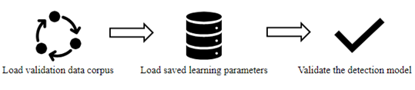  
**Figure 7. Architecture diagram of Model validation**

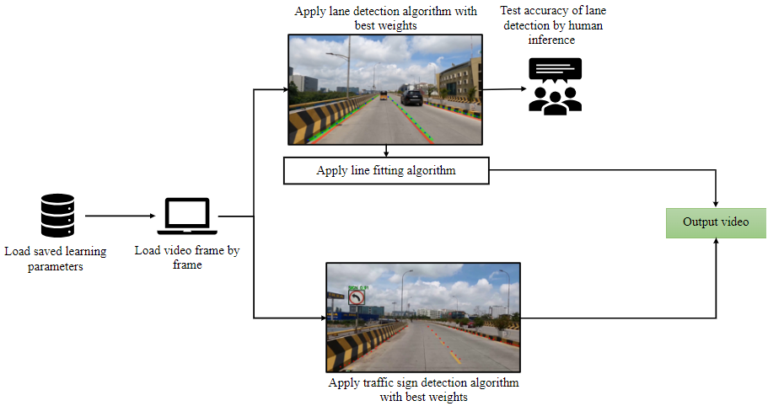**Figure 8. Architecture Diagram of Model Testing**

1. EXPERIMENTATION AND RESULTS

Primarily, the experimentation was conducted on a total of 4110 images i.e., 2055 images in each category with real-world Indian driving scenarios covering urban, suburban, and highway conditions from recent 2 years with a resolution of 1920 x 1080 pixels using a NVIDIA GeForce GTX 1050 Ti with 8GB RAM. The image size considered was 640 in the batches of 8 over 100 epochs. Later, to reduce the risk of overfitting, the dataset was expanded to 22,400 images where the dataset dedicated to lane and traffic sign detection incorporates five distinct categories: crowd, curve, day, cloud/mist, and night/sunset, each comprising exactly 2000 images. Furthermore, the sign dataset integrates instances denoted as partially occluded and erased, with 2400 images. To ensure robust model training, each category is divided into training and testing subsets using a 70-30 split, thereby maintaining unbiased representation across all categories which is a crucial step for accurate model training and evaluation.

* 1. Benchmark Datasets Sample

CeyMo Road Marking Dataset has been considered as benchmark dataset for lane detection with 2887 images with a resolution of 1920 × 1080 pixels. It contains a total of 4,706 road marking instances in varied challenges like Normal, Crowded, light, Night, Rain, and Shadow in urban, suburban, and rural scenarios as shown in Figure 9. For sign detection, GTSDB benchmark dataset, consisting of 900 images with varying traffic signs sizes from 16x16 to 128x128, has been used, and the sample is shown in Figure 10.

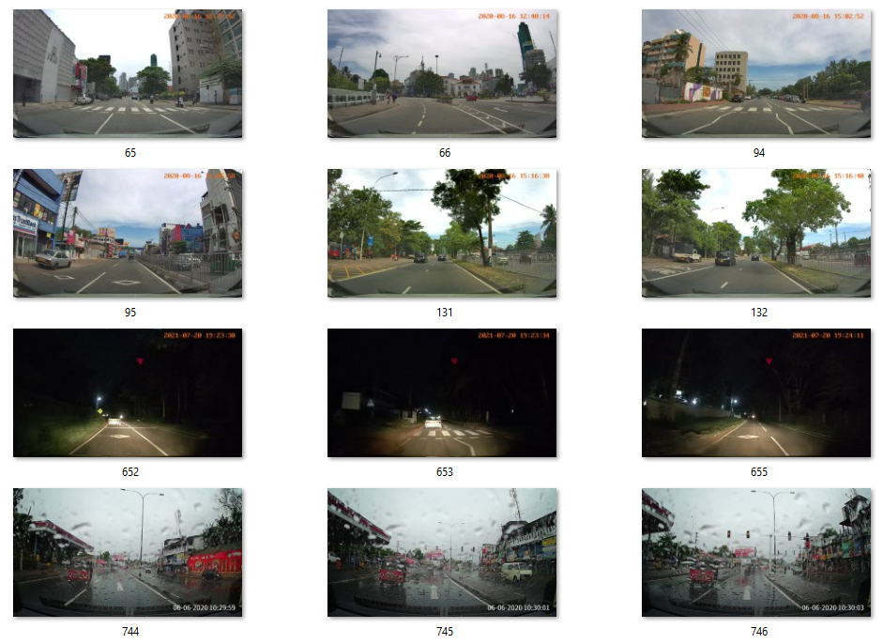**Figure 9. CeyMo Road Marking Dataset sample for lane detection**

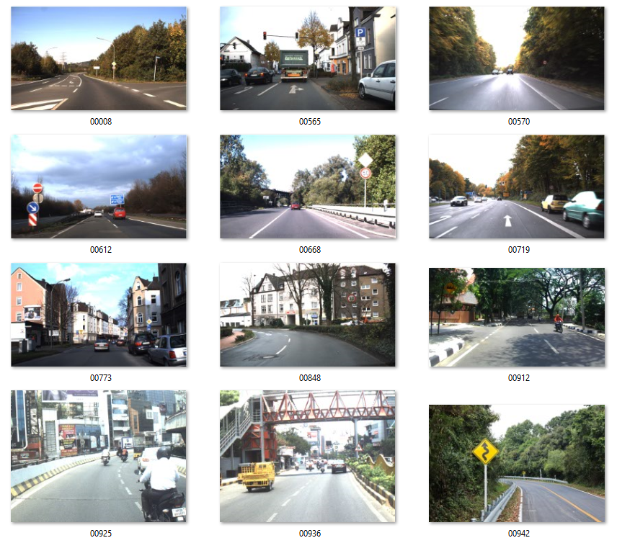**Figure 10. GTSDB Dataset sample for sign detection**

* 1. Custom Dataset Sample

The lane dataset has mainly five instances such as crowd, curves, day/early morning, mist/fog/rain/cloudy, and night/sunset whereas the sign dataset has two additional instances like partially occluded and partially visible in Indian diverse conditions. Figure 11 shows the lane dataset sample and Figure 12 shows the sign dataset sample.

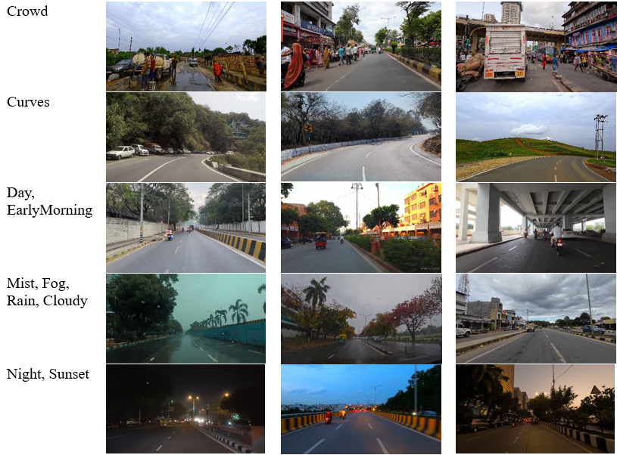  
**Figure 11. Lane dataset sample in diverse environmental and road conditions**

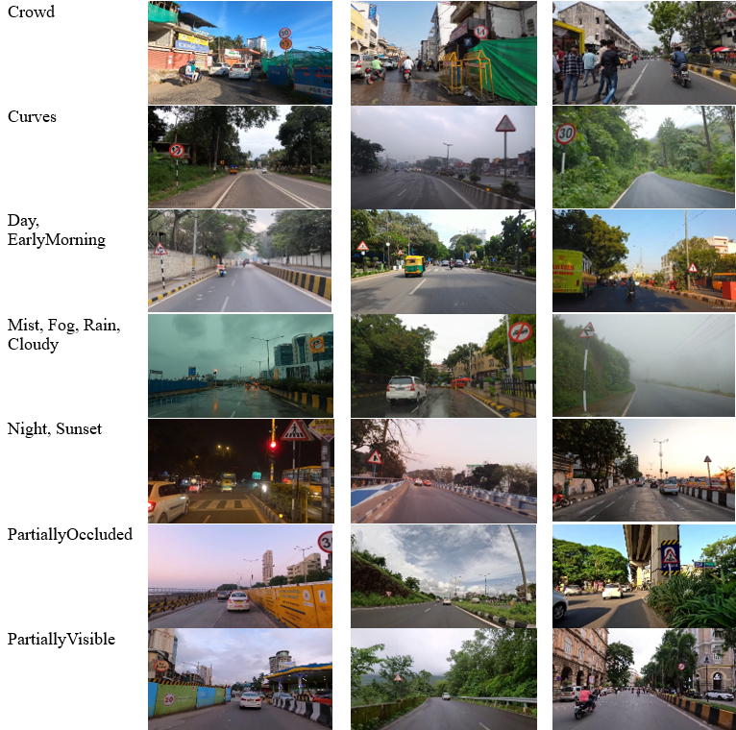

**Figure 12. Sign dataset sample in diverse environmental and road conditions**

* 1. Lane Experimentation with Results

The experimentation and results are discussed with the initial dataset, benchmark datasets, and the expanded datasets for lane models. The Lane Dataset is experimented with using various YOLOv8n models varying in architecture and the model that resulted in the best results is experimented with the expanded dataset.

* + 1. Experimentation on initial Lane Dataset

Initially, the YOLOv8n model with few additional modifications with respect to the layers was carried out with incorporation of CBAM and the results comparison can be seen in Table 1. The YOLOv8n Segmentation model utilizes three layers namely P3, P4, and P5 for feature extraction, while incorporating CBAM does not yield significant improvements. In contrast, the YOLOv8n Segmentation P6 model, incorporating four layers i.e., P3, P4, P5, and P6, achieves a mAP of 94.2%. Despite CBAM's incorporation into the YOLOv8n Segmentation P6 model, which increases computational complexity making it a heavy model, the performance is not notably enhanced compared to the YOLOv8n Seg P6 model. The comparison is visually represented in Figure 13.

**Table 1. FPS comparison across various YOLOv8n Lane models**

|  |  |
| --- | --- |
| **Models** | **FPS** |
| YOLOv8n Segmentation | 108 |
| YOLOv8n Segmentation with CBAM | 26 |
| **YOLOv8n Segmentation P6** | **58** |
| YOLOv8n Segmentation P6 with CBAM | 53 |

The YOLOv8n Seg P6 model demonstrates superior performance in lane segmentation tasks, particularly excelling in precision which results in precise lane detection and achieving the highest mAP among compared models represented in Figure 13. Its balanced performance across metrics makes it a compelling choice for lane applications requiring accurate and continuous lane marking detection.

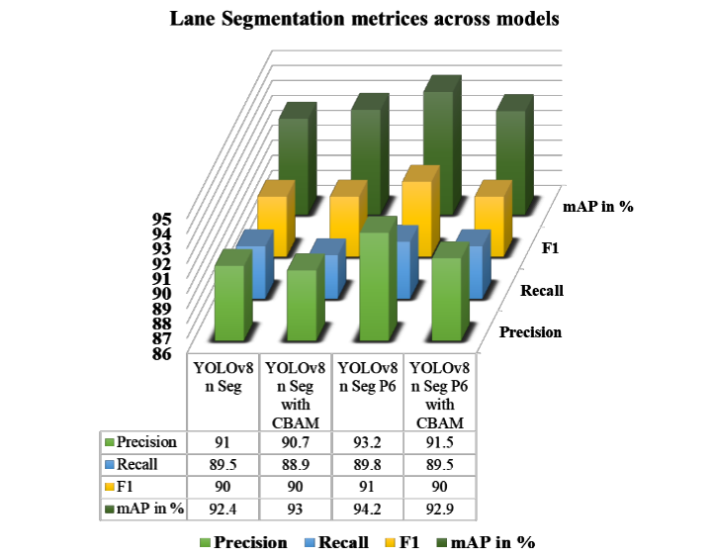  
**Figure 13. Comparison graph of Lane Segmentation metrices across models**

* + 1. Experimentation on expanded Lane Dataset

The experiments were conducted on NVIDIA RTX A2000 with 12GB RAM GPU. After the dataset collection and preparation, the system has been trained using YOLO8n Segmentation P6 model and line fitting algorithm has been employed for precise lane segmentation during Testing phase as depicted in Figure 8. The Benchmark Dataset was experimented using an image size of 1088 in batch of 16 over 200 epochs whereas the custom dataset was experimented with an image size of 1088, batch size of 16 over 100 epochs. The experiments on Benchmark dataset resulted in 67.7% mAP with 56 fps and on the custom dataset, it achieved 90.6% mAP with 117 fps. Table 2 represents the performance comparison between benchmark and custom datasets.

**Table 2. Performance comparison across Benchmark and Custom Lane datasets**

|  |  |  |  |  |  |
| --- | --- | --- | --- | --- | --- |
| **Dataset** | **Precision in %** | **Recall in %** | **F1 in %** | **mAP in %** | **FPS** |
| Benchmark Dataset | 73.9 | 62.9 | 68 | 67.7 | 56 |
| Custom Dataset | 89 | 85.5 | 87 | 90.6 | 117 |

In the evaluation of the model performance as represented in Figure 15, notable trends emerge: training and validation losses consistently decrease, indicating continuous learning and model enhancement. Concurrently, precision and recall metrics exhibit an upward line till 0.8, signifying improvements in both the accuracy and predictions whereas in Figure 14, the predictions are accurate in 0.6 which exhibits a mediocre performance.

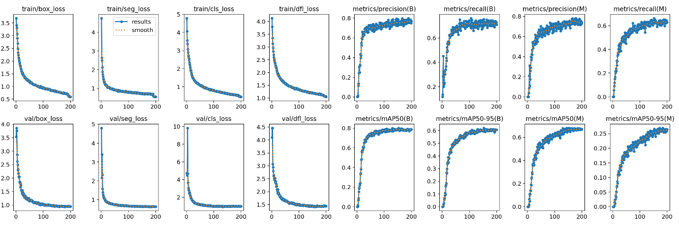  
**Figure 14. Performance Chart of Lane Segmentation on Benchmark Dataset**

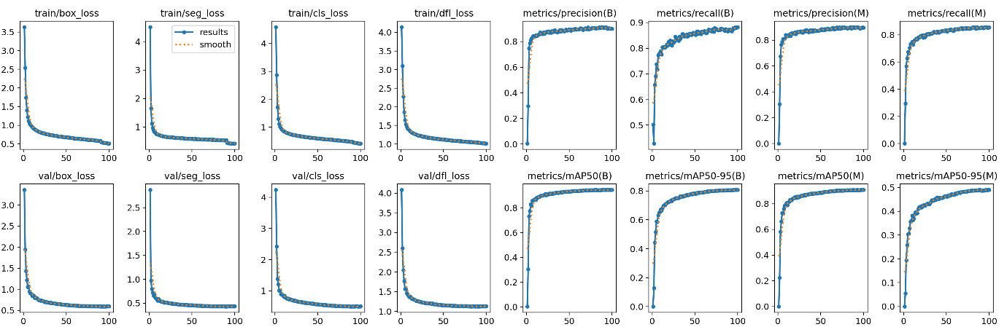

**Figure 15. Performance Chart of Lane Segmentation on Custom Dataset**

Test dataset instances with input images, ground truth masks, and detected lane segmentation output are presented in Figure 16. Ground truth masks aid in accurate lane marking detection, while detected lanes are highlighted in green in the output images. A blue line fitting mask assists in precisely outlining lane markings. This comparison demonstrates the effective model parameter learning across diverse conditions, ensuring reliable lane detection in varied scenarios. As the model does not provide any precision score for the detected lane, Dice Coefficient was employed, and it resulted in 0.72% and also human interpretation for lane detection is considered to obtain a score and it resulted in an average precision of 90.04% as represented in Figure 17.

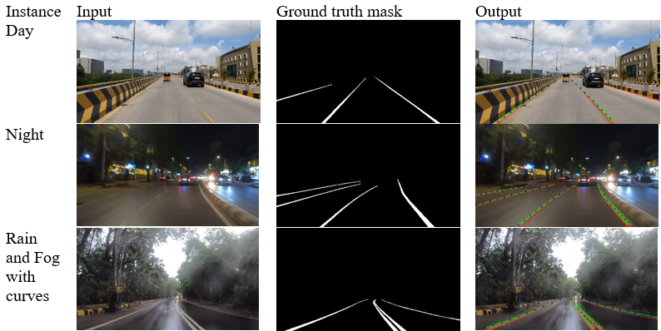**Figure 16. Output of Lane Detection**

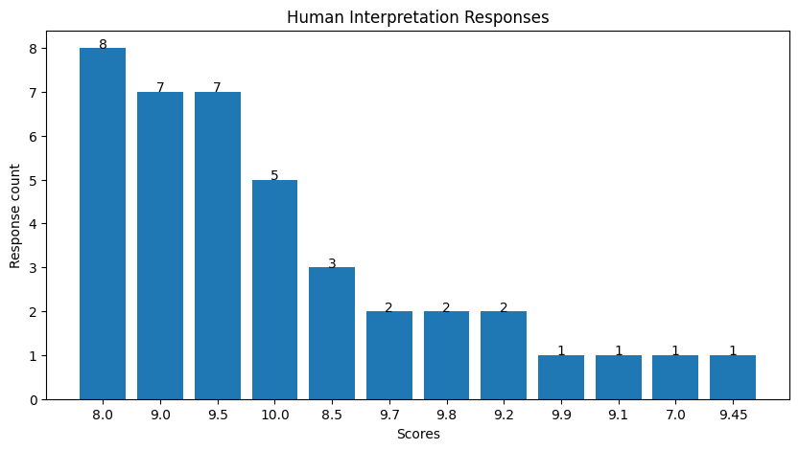

**Figure 17. Precision of Lane detection compared to actual lane marking from human interpretation**

* 1. Sign Experimentation with Results

The experimentation and results are discussed with the initial dataset, benchmark datasets, and the expanded datasets for traffic signs models. The traffic sign Dataset is experimented with using various YOLOv8n models varying in architecture and the model that resulted in the best results is experimented with the expanded dataset.

* + 1. Experimentation on initial Sign Dataset

YOLOv8n model has been implemented by differing its structure by employing Ghost network in the backbone and including CBAM and data augmentation. The models comparison of the same is given in Table 3 where the model YOLOv8n Detection P2 Ghost and CBAM in backbone and Augmentation has resulted in highest mAP of 84.4%. The YOLOv8n Detection P2 model employs four layers, namely P2, P3, P4, and P5, for feature extraction. Conversely, the YOLOv8n Detection P6 model, integrating Ghost in the backbone, utilizes four layers but demonstrates minimal improvement compared to the Detection P2 model.

**Table 3. FPS comparison across various YOLOv8n Sign models**

|  |  |
| --- | --- |
| **Models** | **FPS** |
| YOLOv8n Detection P2 | 147 |
| **YOLOv8n Detection P2 Ghost and CBAM in backbone and Augmentation** | **23** |
| YOLOv8n Detection P6 Ghost in backbone | 54 |

The YOLOv8n P2 model with Ghost and CBAM in the backbone enhanced by data augmentation demonstrated higher performance depicted in Figure 18, exhibiting the highest mAP, recall and F1 scores, indicating accurate detection and high confidence in predictions. However, its precision was slightly lower compared to the other models, suggesting potential missed detections. Incorporating Ghost and CBAM into the model led to improvements in mAP and recall, although with a minor tradeoff.

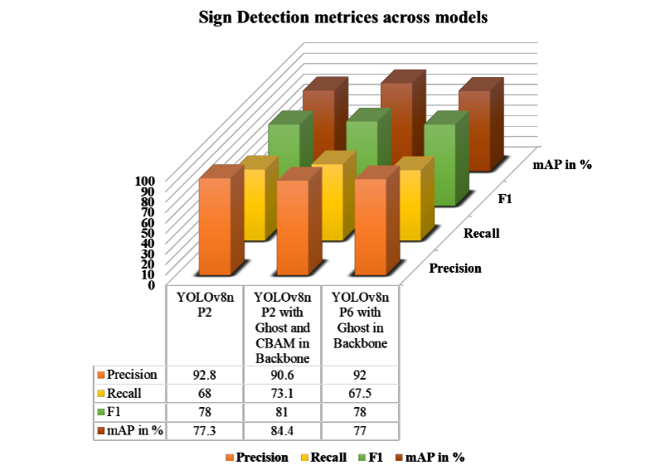

**Figure 18. Comparison graph of Sign Detection metrices across models**

* + 1. Experimentation on expanded Sign Dataset

The system has been trained using YOLOv8n Detection P2 Ghost and CBAM in backbone and Augmentation model. The Benchmark Dataset was experimented using an image size of 1088 in batches of 16 over 200 epochs whereas the custom dataset was experimented with an image size of 1088, batch size of 16 over 100 epochs. The experiments on Benchmark dataset resulted in 59% mAP with 52 fps and on the custom dataset, it achieved 81.3% mAP with 56 fps. The incorporation of Ghost and CBAM in the backbone, coupled with data augmentation, significantly improved detection performance, highlighting the effectiveness of this model configuration for traffic sign detection tasks. Table 4 represents the performance comparison between benchmark and custom datasets.

**Table 4. Performance Comparison across Benchmark and Custom Sign Datasets**

|  |  |  |  |  |  |
| --- | --- | --- | --- | --- | --- |
| **Dataset** | **Precision in %** | **Recall in %** | **F1 in %** | **mAP in %** | **FPS** |
| Benchmark Dataset | 79.1 | 53.8 | 64 | 59 | 52 |
| Custom Dataset | 84.7 | 71.4 | 77 | 81.3 | 56 |

The loss graphs mentioned in Figure 20, show an initial rapid decrease, indicating effective learning, while the metrics graphs illustrate a steady increase in model performance over time. Specifically, the precision and recall metrics improve as the model trains, leading to better overall performance. The metrics graph of Figure 19 shows the performance indicating a mediocre accuracy in detecting signs.

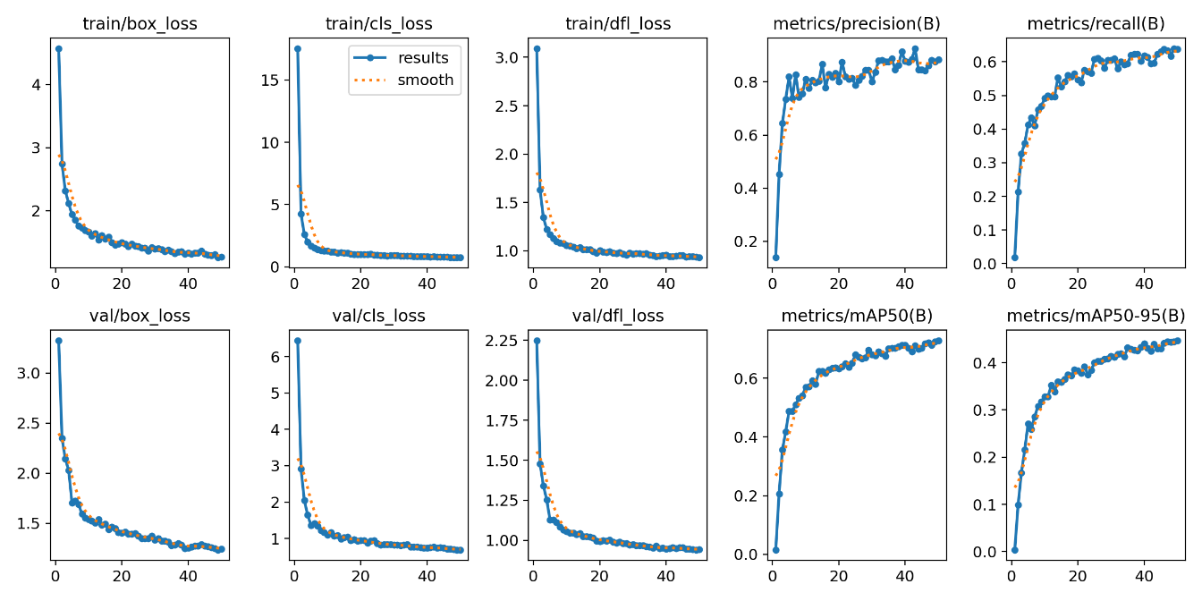

**Figure 19. Performance Chart of Sign Detection on Benchmark Dataset**

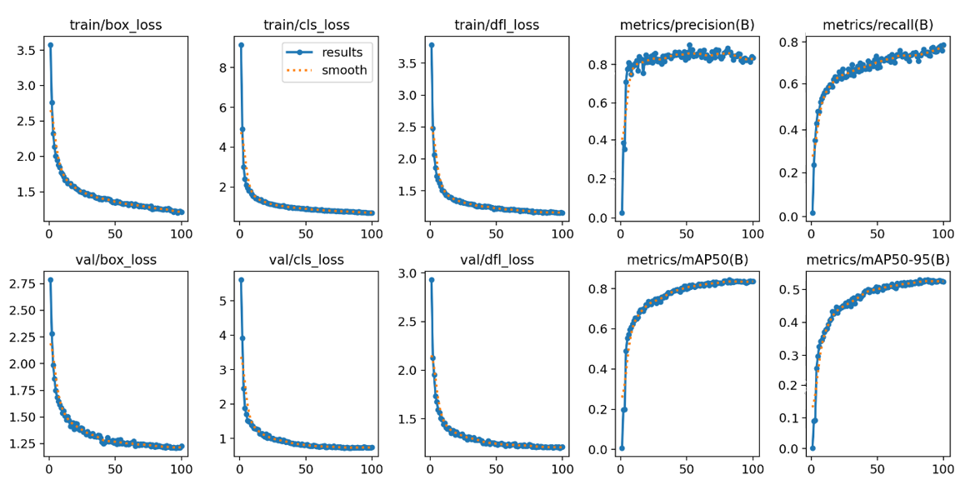**Figure 20. Performance Chart of Sign Detection on Custom Dataset**

The sign detection output of both day and nighttime scenarios are given in Figure 21, where each image includes a bounding box outlining the detected traffic sign, accompanied by a precision value indicating the correctness of the detection whereas an average it is obtained as 80% precision which is notable. To assess the performance of the detection, IoU was employed which resulted in 0.91% which is impressive.

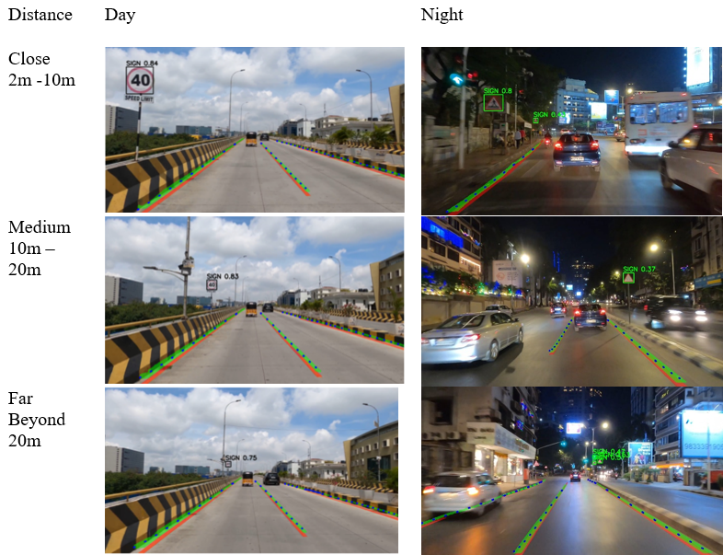

**Figure 21. Output of Sign Detection**

4.5 Benchmark Dataset vs Indian Dataset Testing Analysis

In Figure 22, the left-side images depict the testing performance of the model trained using an Indian dataset, while the right-side images represent the model performance trained using the benchmark dataset. The comparison focuses on testing scenarios specific to Indian road conditions, with varied lighting conditions such as night, day, and rainy environments, as well as challenges posed by crowded roads, partially occluded and partially erased traffic signs and lane markings. The test performance of model trained on benchmark dataset reveals limitations in handling these complex Indian scenarios, particularly in effectively sophisticated muddled road conditions in urban and suburban scenarios. As illustrated in Figure 22, a(i) and a(ii), the sign is partially erased, and the lane markings are feeble. Nonetheless, the model accurately detects them in a(i) compared to a(ii). In Figure 22 b(i) and b(ii), although lane markings and the small traffic sign are present, it is not detected as accurate and precise as in b(i).

**Trained using Indian Dataset**  **Trained using Benchmark Dataset**

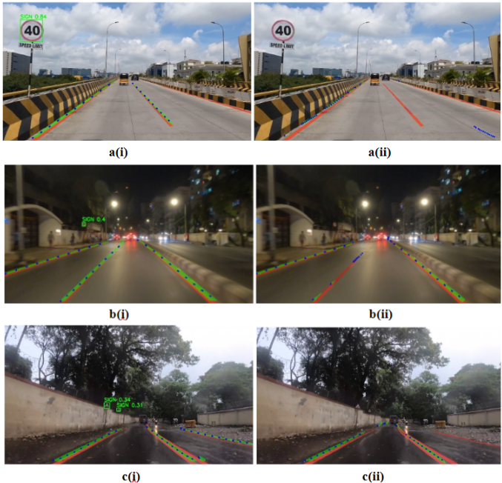

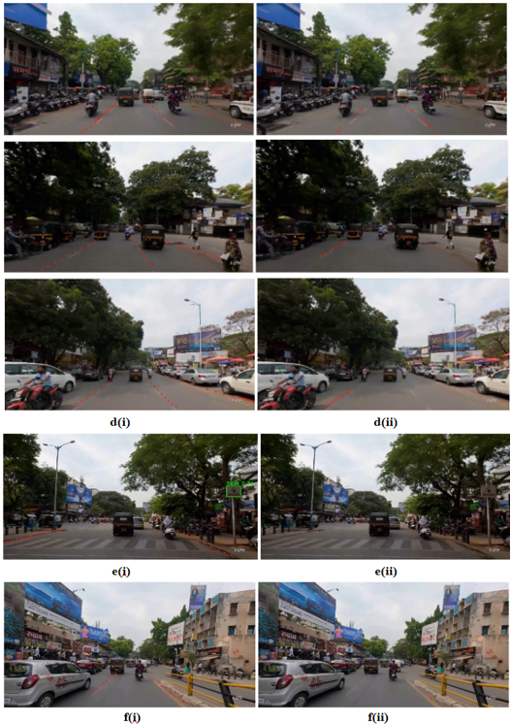

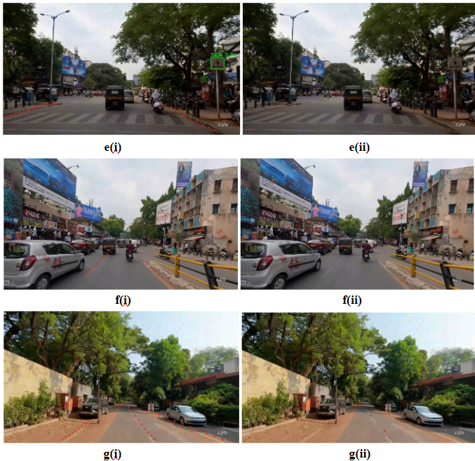**Figure 22. Comparison of testing performance on Indian Dataset trained model vs. Benchmark Dataset trained model**

Indian traffic conditions are often a rush with people, vehicles and often with animals positioned haphazardly on the road. Despite these challenges, the model detects the lanes more accurately as seen in Figure 22 d(i) compared to d(ii). In Figure 22 e(i) and e(ii), the sign is partially erased and overshadowed by the trees around making it hard to spot from a distance and the lane markings are feeble. Nonetheless, the model accurately detects them in e(i) compared to e(ii). The Indian dataset includes scenarios such as rain-soaked roads leading to washed-out lane markings, silt filled roads and small sign boards as depicted in Figure 22 c(i) and c(ii), crowded roads with vehicles near lane markings in Figure 22 f(i) and f(ii), though the roads are clear from traffic, we can see muddy roads and muddled lanes due to poor maintenance as represented in Figure 22 g(i) and g(ii). Regardless of these challenges, the Indian dataset has achieved higher precision in detecting lanes and signs compared to the benchmark dataset.

4.6 Evaluation Metrics

To assess the consistency of the outcomes during the testing phase, the metrices like precision, recall, F1-score, mAP and fps are utilized. Accurate identification of lanes and signs is ensured by precision. The model's entire detection potential is captured by mAP. The F1 score reflects the effectiveness of the model by balancing Precision and Recall. FPS assesses the ability of real-time processing of the model in detecting the lanes and signs. These metrices allows to measure the object detection capabilities. Precision(P) measures how the model can label an object. Recall(R) gauges how well the model identifies an object. False Positives (FP) signify incorrect detections, True Negatives (TN) indicate correctly identified non-instances, and True Positives (TP) show accurately identified instances. On the other hand, False Negatives (FN) indicate missing detections.

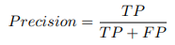

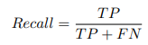

The F1-Score measures how well the model can correctly identify object. Mean Average Precision (mAP) provides a detailed evaluation of the model’s performance by taking the mean/average of all the average precision.

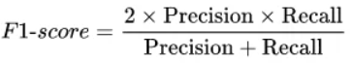

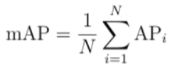

where N is the number of classes, and APi represents the Average Precision for the i-th class.

Furthermore, the quantity of the frames per second (FPS) is used to measure how quickly the algorithm detects motion which aids in real-time detection. Here, it means the system processes 1 frame per second at an inference speed of 1000 milliseconds.

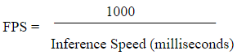

In segmentation tasks, the Dice Coefficient metric works in a pixel level as it compares pixels with pixels helping in assessing the segmentation. It determines how closely the ground truth mask and the predicted mask overlay and gives a score between 0 and 1, where 0 represents no overlay and 1 represents perfect overlay of masks.

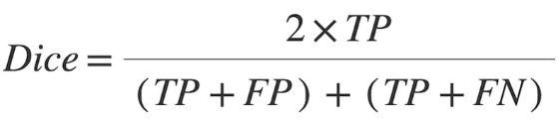

In detection tasks, the Intersection over Union (IoU) metric determines how much the ground truth box and predicted box overlap. The value is in the range of 0 and 1, where 0 denotes no overlap and 1 denotes perfect overlap.

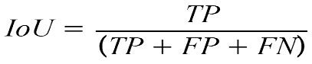

1. CONCLUSION

In a nutshell, the development of the model for lane detection and traffic sign detection represents a significant advancement in autonomous driving systems. The utilization of layers from P3 to P6 in the head of the architecture contributes to addressing the challenge of detecting lanes and signs even when they are partially occluded and partially visible in diverse Indian scenarios, demonstrating the model's efficiency. Regardless of the challenges of YOLOv8, the precision obtained for the proposed model is remarkable. For lane detection, the YOLOv8n Seg P6 model achieves an impressive training mAP of 90.6%, and precision is obtained by the human interpretation, which is 90.4% with a Dice Coefficient of 0.72%. Regarding traffic sign detection, the YOLOv8n P2 model, enhanced with Ghost and CBAM, along with data augmentation techniques that have enhanced confidence in predictions, achieves a training mAP of 81.3% and a precision of around 80% prediction score given by the model with an IoU of 0.91%. Even though concerns about consistency and computational expenses associated with model enhancements persist, the YOLOv8-based approach outperforms alternative models in terms of mAP and F1 scores, showcasing its effectiveness concerning precision and accurate detection. However, further research is essential to optimize model architectures for improved performance under varying hardware constraints and to enhance the robustness of the system in real-time deployment. Despite these challenges, the YOLOv8-based model offers a promising solution for precise and efficient lane and traffic sign detection, thereby contributing to the advancement of autonomous driving technologies. This study addresses the specific challenges of Indian roads that are not adequately approached by current state-of-the-art models, providing a solution tailored to the unique conditions of Indian urban, suburban, and highway environments. Training the model with benchmark datasets and testing on Indian datasets resulted in suboptimal performance, whereas training the model with Indian datasets and testing on Indian datasets yielded significantly improved results, thereby highlighting the importance training Indian data for enhancing model accuracy and reliability in real-world applications.

REFERENCES

1. Luo, Y., Ci, Y., Jiang, S., & Wei, X. (2024). A novel lightweight real-time traffic sign detection method based on an embedded device and YOLOv8. Journal of Real-Time Image Processing, 21(2), 24.
2. Soylu, E., & Soylu, T. (2023). A performance comparison of YOLOv8 models for traffic sign detection in the Robotaxi-full scale autonomous vehicle competition. Multimedia Tools and Applications, 1-31.
3. An Improved Traffic Sign Recognition and Road Lane Detection for Self-Driving Cars using YOLO-v8 - Divya - IJFMR Volume 5, Issue 6, November-December 2023. DOI 10.36948/ijfmr.2023.v05i06.9675
4. https://icaiit.org/paper.php?paper=11th_ICAIIT_2/2_3
5. Zhang, L. J., Fang, J. J., Liu, Y. X., Feng Le, H., Rao, Z. Q., & Zhao, J. X. (2023). CR-YOLOv8: Multiscale object detection in traffic sign images. IEEE Access, 12, 219-228.
6. Wang, H., Han, X., Song, X., Su, J., Li, Y., Zheng, W., & Wu, X. (2024). Research on automatic pavement crack identification Based on improved YOLOv8. International Journal on Interactive Design and Manufacturing (IJIDeM), 1-11.
7. Liu, Q., Ye, H., Wang, S., & Xu, Z. (2024). YOLOv8-CB: Dense Pedestrian Detection Algorithm Based on In-Vehicle Camera. Electronics, 13(1), 236.
8. Kumar, D., & Muhammad, N. (2023). Object detection in adverse weather for autonomous driving through data merging and YOLOv8. Sensors, 23(20), 8471.
9. Hoang, T. N., Nguyen, K. H., Hua, H. K., Nguyen, H. V. N., & Quach, L. D. (2023). Optimizing YOLO Performance for Traffic Light Detection and End-to-End Steering Control for Autonomous Vehicles in Gazebo-ROS2. International Journal of Advanced Computer Science and Applications, 14(7).
10. Huang, Z., Li, L., Krizek, G. C., & Sun, L. (2023). Research on traffic sign detection based on improved YOLOv8. Journal of Computer and Communications, 11(7), 226-232.
11. Nabou, A., Salih, A. L., Rabbaa, I. B., Abdelwahed, E. H., & Ouhamou, M. A. A. (2023, November). Road Signs Recognition by Using YOLOv8 Model. In 2023 14th International Conference on Intelligent Systems: Theories and Applications (SITA) (pp. 1-7). IEEE.
12. Wang, J., Wu, Q. M., & Zhang, N. (2023). You Only Look at Once for Real-time and Generic Multi-Task. arXiv preprint arXiv:2310.01641.
13. Zhao, S., Gong, Z., & Zhao, D. (2024). Traffic signs and markings recognition based on lightweight convolutional neural network. The Visual Computer, 40(2), 559-570.
14. Hotkar, O., Radhakrishnan, P., Singh, A., Jhamnani, N., & Bidwe, R. V. (2023, August). U-Net and YOLO: AIML Models for Lane and Object Detection in Real-Time. In Proceedings of the 2023 Fifteenth International Conference on Contemporary Computing (pp. 467-473).
15. Song, X., Che, X., Jiang, H., Yan, S., Li, L., Ren, C., & Wang, H. (2022). A Robust Detection Method for Multilane Lines in Complex Traffic Scenes. Mathematical Problems in Engineering, 2022.
16. Wang, B., Yan, X., & Li, D. (2022). An end-to-end lane detection model with attention and residual block. Computational intelligence and neuroscience, 2022.
17. Yao, Z., & Chen, X. (2022). Efficient lane detection technique based on lightweight attention deep neural network. Journal of Advanced Transportation, 2022.
18. Wu, X., & Cao, H. (2022, April). Traffic Sign Detection Algorithm Based On Improved YOLOv4. In Journal of Physics: Conference Series (Vol. 2258, No. 1, p. 012009). IOP Publishing.
19. Tong, H., Gong, Z., & Jun, S. (2022). Traffic Signs Detection and Recognition Based on the improved YOLOv5 Algorithm.
20. Gu, Y., & Si, B. (2022). A novel lightweight real-time traffic sign detection integration framework based on YOLOv4. Entropy, 24(4), 487.
21. Youssouf, N. (2022). Traffic sign detection and recognition with faster-RCNN and YOLOV4. Available at SSRN 4012734.
22. Shivayogi, A. B., Dharmendra, N. C. M., Ramakrishna, A. M., & Subramanya, K. N. (2023). Real-Time Traffic Sign Recognition Using Deep Learning. Pertanika Journal of Science & Technology, 31(1).
23. Wang, Y., Bai, M., Wang, M., Zhao, F., & Guo, J. (2022). Multiscale traffic sign detection method in complex environment based on YOLOv4. Computational intelligence and neuroscience, 2022.
24. Hassan, S. A., Rahim, T., & Shin, S. Y. (2021). An improved deep convolutional neural network-based autonomous road inspection scheme using unmanned aerial vehicles. Electronics, 10(22), 2764.
25. Ji, G., & Zheng, Y. (2021). Lane line detection system based on improved Yolo V3 algorithm.
26. Zhang, R., Wu, Y., Gou, W., & Chen, J. (2021). RS-lane: A robust lane detection method based on Resnest and self-attention distillation for challenging traffic situations. Journal of advanced transportation, 2021, 1-12.
27. Wang, R., Wang, Z., Xu, Z., Wang, C., Li, Q., Zhang, Y., & Li, H. (2021). A real-time object detector for autonomous vehicles based on YOLOv4. Computational Intelligence and Neuroscience, 2021.
28. Dou, H., Zhang, H., & Li, B. (2021, April). A fast traffic sign detection algorithm based on modified YOLOv3. In Journal of Physics: Conference Series (Vol. 1880, No. 1, p. 012025). IOP Publishing.
29. Dewi, C., Chen, R. C., Liu, Y. T., Jiang, X., & Hartomo, K. D. (2021). Yolo V4 for advanced traffic sign recognition with synthetic training data generated by various GAN. IEEE Access, 9, 97228-97242.
30. Wang, L., Zhou, K., Chu, A., Wang, G., & Wang, L. (2021). An improved light-weight traffic sign recognition algorithm based on YOLOv4 Tiny. IEEE Access, 9, 124963-124971.
31. Zayed, M. M., Al Amin, M., & Rahman, M. S. Real-time Detection and Recognition of Traffic Signs in Bangladesh using YOLOv3 Detector.
32. Duan, H., Zhu, H., & Chen, F. (2020, November). A Method of lane detection Based on a Hybrid Model in Urban Environment. In 2020 Chinese Automation Congress (CAC) (pp. 7417-7422). IEEE.
33. Avramović, A., Sluga, D., Tabernik, D., Skočaj, D., Stojnić, V., & Ilc, N. (2020). Neural-network-based traffic sign detection and recognition in high-definition images using region focusing and parallelization. IEEE Access, 8, 189855-189868.
34. Yang, W., & Zhang, W. (2020, October). Real-time traffic signs detection based on YOLO network model. In 2020 International Conference on Cyber-Enabled Distributed Computing and Knowledge Discovery (CyberC) (pp. 354-357). IEEE.
35. Wang, H., & Yu, H. (2020, December). Traffic sign detection algorithm based on improved YOLOv4. In 2020 IEEE 9th Joint International Information Technology and Artificial Intelligence Conference (ITAIC) (Vol. 9, pp. 1946-1950). IEEE.
36. Hou, Y., Ma, Z., Liu, C., & Loy, C. C. (2019). Learning lightweight lane detection cnns by self attention distillation. In Proceedings of the IEEE/CVF international conference on computer vision (pp. 1013-1021).
37. Rajendran, S. P., Shine, L., Pradeep, R., & Vijayaraghavan, S. (2019, July). Real-time traffic sign recognition using YOLOv3 based detector. In 2019 10th international conference on computing, communication and networking technologies (ICCCNT) (pp. 1-7). IEEE.
38. Zhang, X., Yang, W., Tang, X., & Liu, J. (2018). A fast learning method for accurate and robust lane detection using two-stage feature extraction with YOLO v3. Sensors, 18(12), 4308.
39. Zeng, G.; Wu, Z.; Xu, L.; Liang, Y. Efficient Vision Transformer YOLOv5 for Accurate and Fast Traffic Sign Detection. Electronics 2024, 13, 880. https://doi.org/10.3390/electronics13050880
40. Flores-Calero, M.; Astudillo, C.A.; Guevara, D.; Maza, J.; Lita, B.S.; Defaz, B.; Ante, J.S.; Zabala-Blanco, D.; Armingol Moreno, J.M. Traffic Sign Detection and Recognition Using YOLO Object Detection Algorithm: A Systematic Review. Mathematics 2024, 12, 297. https://doi.org/10.3390/math12020297
41. https://www.researchgate.net/publication/282813698_On_the_Use_of_Convolutional_Neural_Networks_and_Augmented_CSP_Features_for_Multi-class_Motor_Imagery_of_EEG_Signals_Classification
42. https://medium.com/@juanpedro.bc22/detailed-explanation-of-yolov8-architecture-part-1-6da9296b954e
43. https://medium.com/@epcm18/image-resampling-in-image-processing-f7b597ee78a8#:~:text=Now%2C%20the%20nearest%20neighbor%20method,pixel%20in%20the%20original%20image
44. https://paperswithcode.com/method/ghost-module
45. https://paperswithcode.com/method/cbam